SUMMER TASKS – GCSE TO A Level TRANSITION
Subject: Media Studies
Title: Strange Media
Task(s):

In preparation for joining the course in September, it would be really helpful if you could carry out both of the following tasks. We will spend time in our first week discussing these:

1. Analyse the poster for Stranger Things Season 4 (there’s also a link to the image if you need to see it in higher resolution).

- How does the poster tell us what genre(s) the show belongs to?
- What does the poster tell us the show might be about and how does it do this?
- If you’re familiar with the show, how does the image link into previous seasons?
- If you’re not familiar with the show, how effective is the image in making you want to watch it?

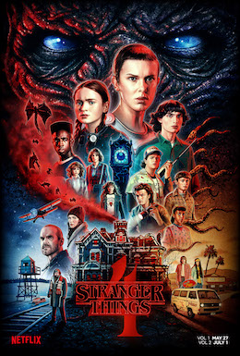
Stranger Things season 4 - Stranger Things (season 4) - Wikipedia

2. Pick a film, television show or video game that you don’t know much about and create an information sheet that explains:

- Who you think the target audience is (age, gender, similar tastes, etc.)
- The main companies involved in producing (making) it and distributing (how it gets to us: streaming, traditional television channels, etc.)
- The genre (style of product) it belongs to and what it has in common with other programmes from that genre.

You can bring your completed work to your first lesson, or email it to brittany-clarke@yorkcollege.ac.uk. If you have any problems or questions, just email!

We look forward to seeing you in September!

The Media Studies Team.

How long should I spend on this? Approx 1 hour
How will I get feedback? Verbal feedback in class
Contact email: brittany-clarke@yorkcollege.ac.uk

