SUMMER TASKS – GCSE TO A-LEVEL TRANSITION
Subject: A-Level Politics
Title: Has Keir Starmer had a successful first year as Prime Minister?
Task:
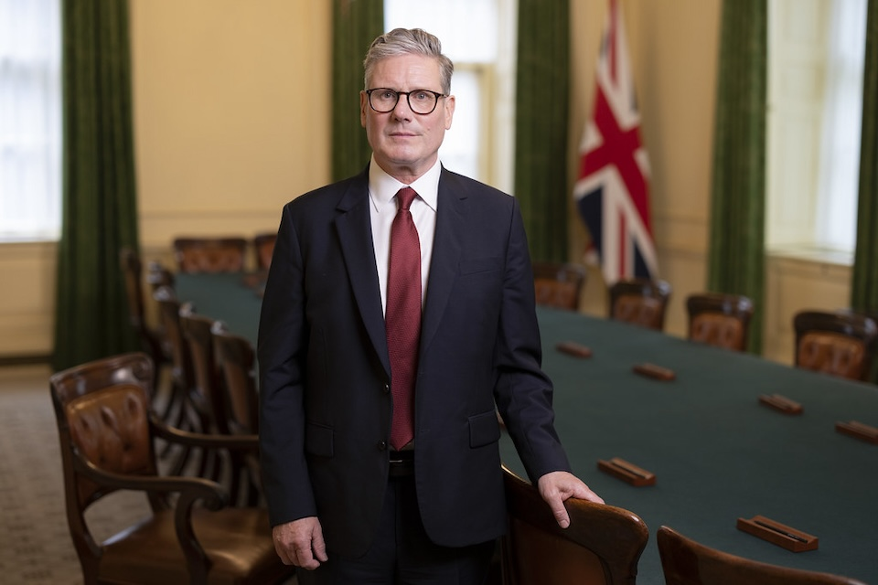

Sir Keir Starmer became Prime Minister on 5 July 2025 after the general election, winning 411 out of a possible 650 seats (albeit with only 34% of the votes and on a turnout of 60% of registered voters). How has his Labour government performed since? What have been its successes and failures? Overall, would you argue that Keir Starmer has had a successful first year as Prime Minister?
In A Level Politics you are required to weigh up different arguments and to come to your own conclusions. You are going to do about 40 minutes of research and then write up your view to the question above. A number of issues have been selected for you below with hyperlinks.

Please bring Task B to your first Politics class, handwritten on A4 paper with your name on it.

Task A: Research
Use the hyperlinks provided only to research each issue and take notes on your own version of the table below. For each issue you can make notes under either one column (successful/unsuccessful) or both, depending on what you read.
Labour’s manifesto
Issue | Shows Labour have been successful | Shows Labour has been unsuccessful
Winter fuel payments

Gifts row

Minimum wage

Zero hours contracts

Economic growth

Relations with President Trump and the Anglo-US trade deal

Immigration

Two-child cap on child benefit [July 2024]
The rise of Reform UK:
Act now to win back Red Wall voters, Labour MPs say - BBC News

Keir Starmer: Nigel Farage would crash economy like Liz Truss - BBC News

Net zero

(Explainer)

Defence and foreign aid budget

Plans to cut disability payments

Gaza

Starmer’s popularity in the polls

Task B: Has Keir Starmer had a successful first year as Prime Minister?
This is your opportunity to summarise the argument that Starmer has been successful and the counter-argument.
Summary of the ways that Starmer has been successful
……………………………………………………………………………………………………………………………………
……………………………………………………………………………………………………………………………………
……………………………………………………………………………………………………………………………………
……………………………………………………………………………………………………………………………………
……………………………………………………………………………………………………………………………………
……………………………………………………………………………………………………………………………………
……………………………………………………………………………………………………………………………………
……………………………………………………………………………………………………………………………………
……………………………………………………………………………………………………………………………………
Summary of the ways that Starmer has been unsuccessful
……………………………………………………………………………………………………………………………………
……………………………………………………………………………………………………………………………………
……………………………………………………………………………………………………………………………………
……………………………………………………………………………………………………………………………………
……………………………………………………………………………………………………………………………………
……………………………………………………………………………………………………………………………………
……………………………………………………………………………………………………………………………………
……………………………………………………………………………………………………………………………………
……………………………………………………………………………………………………………………………………
Having considered the examples of Starmer being successful and unsuccessful, I have concluded that overall Starmer has been
……………………………………………………………………………………………………………………………………
……………………………………………………………………………………………………………………………………
……………………………………………………………………………………………………………………………………
……………………………………………………………………………………………………………………………………
……………………………………………………………………………………………………………………………………
……………………………………………………………………………………………………………………………………

This is because
……………………………………………………………………………………………………………………………………
……………………………………………………………………………………………………………………………………
……………………………………………………………………………………………………………………………………
……………………………………………………………………………………………………………………………………
……………………………………………………………………………………………………………………………………
……………………………………………………………………………………………………………………………………
……………………………………………………………………………………………………………………………………
……………………………………………………………………………………………………………………………………
……………………………………………………………………………………………………………………………………
……………………………………………………………………………………………………………………………………
……………………………………………………………………………………………………………………………………
……………………………………………………………………………………………………………………………………
……………………………………………………………………………………………………………………………………
……………………………………………………………………………………………………………………………………
……………………………………………………………………………………………………………………………………

How long should I spend on this? 1hr
How will I get feedback?
Contact email:

