**SUMMER TASKS – GCSE TO A-LEVEL TRANSITION**

|  |
| --- |
| **Subject: A-Level Fine Art** |
| **Title: Summer Task: LAYERS** |
| **Task:**  Make 2 **back-grounds** to work on top of using mixed media to make a piece that is created through building up a series of **LAYERS**. You can make a background using appropriate media such as e.g. tea/coffee staining, ink wash, watercolour wash – the background should be subtle enough to be able to see a drawing or painting that you make on top, the chosen background colour should also be appropriate for what you are drawing e.g. choose greens /browns for a natural subject matter.  <https://www.youtube.com/watch?v=a_bLd8nJeRM>  <https://www.youtube.com/watch?v=BPOzcqSBHOo>   1. Choose **one subject matter** area that interests you from the list of options provided below:  * **Landscape** * **Rural** * **Urban** * **Portraiture** * **Still Life** * **Organic** * **Human Form** * **Manmade**   You will work with your chosen **subject matter** to **produce two practical** pieces of work based on the idea of **LAYERS.**  You will need to either **take photos to work from or have the real-life object** in front of you to draw from!!!  **Create two pieces using LAYERS, remember to work onto the 2 back-grounds you have made:**   1. **Make one piece using DRY MEDIA of your choice** e.g. a quality pencil study using a range of tones with added pen work to produce layers. 2. **Make the second piece using WET MEDIA of your choice** e.g. a piece using watercolour and ink to produce layers.   The **MAIN AIM** with both pieces is to use a series of **LAYERS** to build up the final outcome. **You may also wish to look at existing artists work as sources of inspiration!!!**  **You will hand in the 2 pieces of work in your first Fine Art lesson so the pieces can be assessed.**  **Please see the next page for visual examples of the types of works you may choose to produce and methods used.** |
| **How long should I spend on this? 1hr** |
| **How will I get feedback?** |
| **Contact email:** |

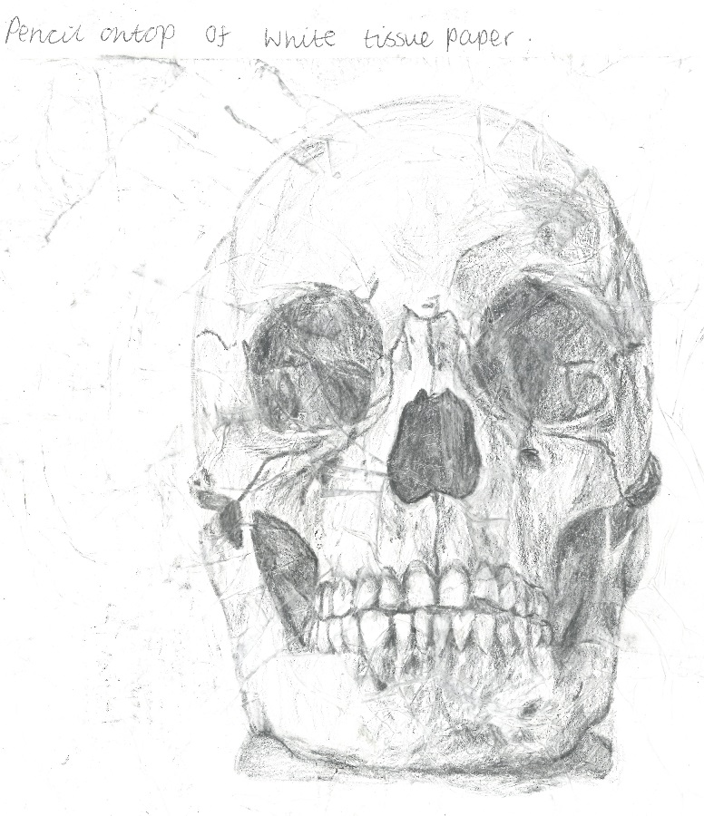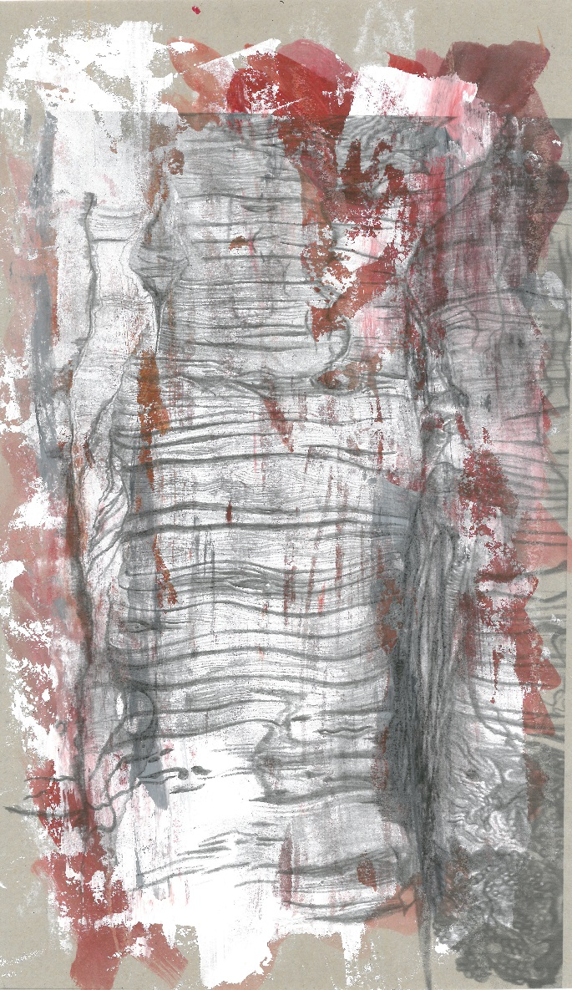

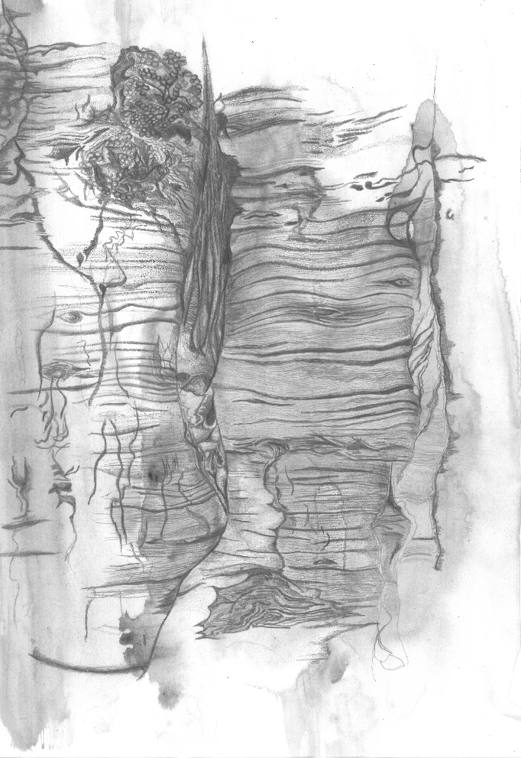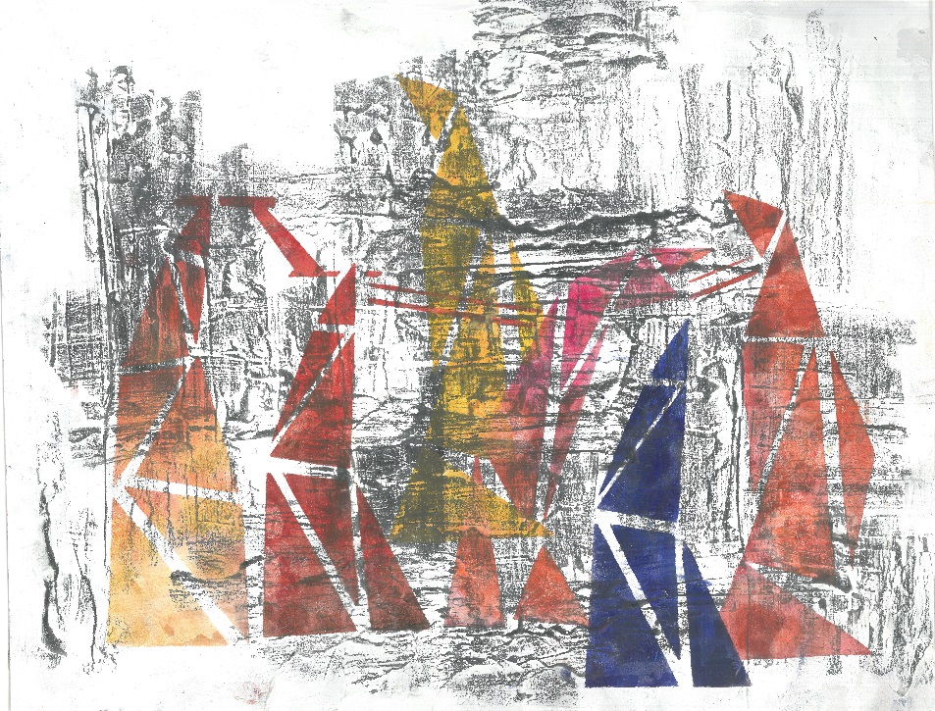

**Skull study** – created through collaging white tissue paper onto cartridge paper then working a range of pencil tones over the top. Could have been ‘aged’ further by using a tea/coffee staining layer under the pencil layer.

**Architectural study** – white emulsion base roughly applied, stencilled structures in watercolour, graphite rub to finish.

**Tree bark study** – created through layering onto coloured paper with white emulsion and burnt sienna acrylic, then working over the top with both pencil and charcoal.

**Tree bark study** – dilute black ink wash, pencil and charcoal drawing over.