**Welcome to the York College Construction Department**

Now that you've enrolled with us, your construction learning journey begins right here.

Before your first lessons start, please complete this workbook by answering all the questions.

Make sure to bring your completed workbook to your first scheduled lesson.

We look forward to seeing you soon! **York College Construction Department**

Student Name:

Course :

**During the first four weeks, we will closely assess and monitor your progress to ensure you're on the right path and working at the appropriate level. This process is known as a Skills Scan.**

**The following activities you complete will contribute to your individual Skills Scan. Please complete the assigned tasks and submit them to your tutor on your first day at College.**

Safety Task

How many hazards can you spot in the image below?

Circle each one you find, then choose **10 hazards** and describe what actions could be taken to eliminate or reduce them.

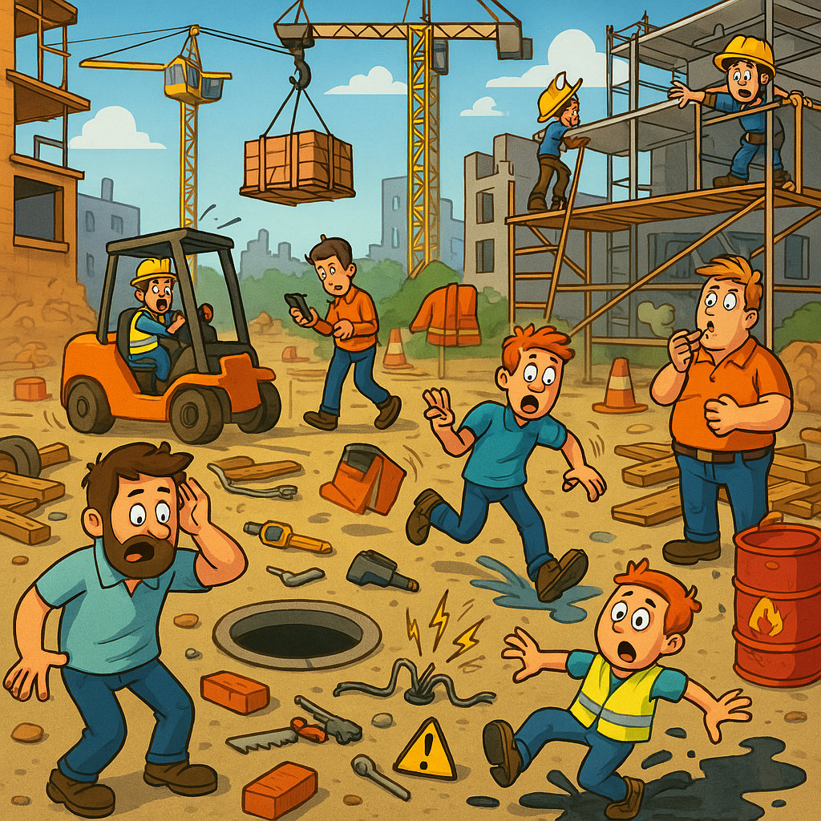

**1** **6**

**2** **7**

**3** **8**

**4** **9**

**5** **10**

**Construction Wordsearch**

All the words in this puzzle are related to construction. They may appear forwards or backwards, horizontally, vertically, or diagonally—but always in a straight line. **Can you find them all?**

|  |  |  |
| --- | --- | --- |
| Bricklayer | Site Carpenter | Furniture Manufacturer |
| Architectural Joiner | Plumber | Electrician |
| Health & Safety | Painter and Decorator | Stonemason |
| Architect | Estimator | Site Manager |
| Surveyor | Ground Worker |  |

**About You**

**Assignment Instructions**

Please complete a short-written assignment based on the questions below. The length of your response should reflect the level of your course.

**Assignment Question:**

**"Why did you choose your construction course? What skills are you hoping to gain, and why are they important to you?"**

**Approximate Word Count Guide:**

* **Multiskills** – 150 words
* **Entry Level 3** – 150 words
* **Level 1** – 300 words
* **Level 2 & Level 3** – 500 words

Your assignment must be **handwritten** on the following pages and submitted during your **first timetabled lesson**.

|  |
| --- |
|  |
|  |
|  |
|  |
|  |
|  |
|  |
|  |
|  |
|  |
|  |
|  |
|  |
|  |
|  |
|  |
|  |
|  |
|  |
|  |
|  |
|  |
|  |
|  |
|  |
|  |
|  |
|  |
|  |
|  |
|  |
|  |
|  |
|  |
|  |
|  |
|  |
|  |
|  |
|  |
|  |
|  |
|  |
|  |
|  |
|  |
|  |
|  |
|  |
|  |

**Tutor Feedback**

|  |
| --- |
|  |
|  |
|  |
|  |
|  |

Signed _________________________________________