SUMMER TASKS – GCSE TO A-LEVEL TRANSITION
Subject: A-Level Early Modern History
Title: Henry VII
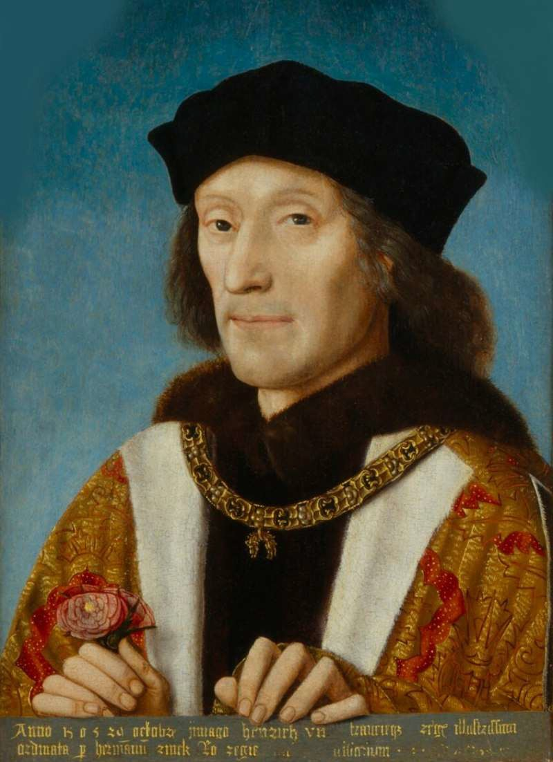
Task:

HOW STRONG WAS HENRY VII’S CLAIM TO THE THRONE?
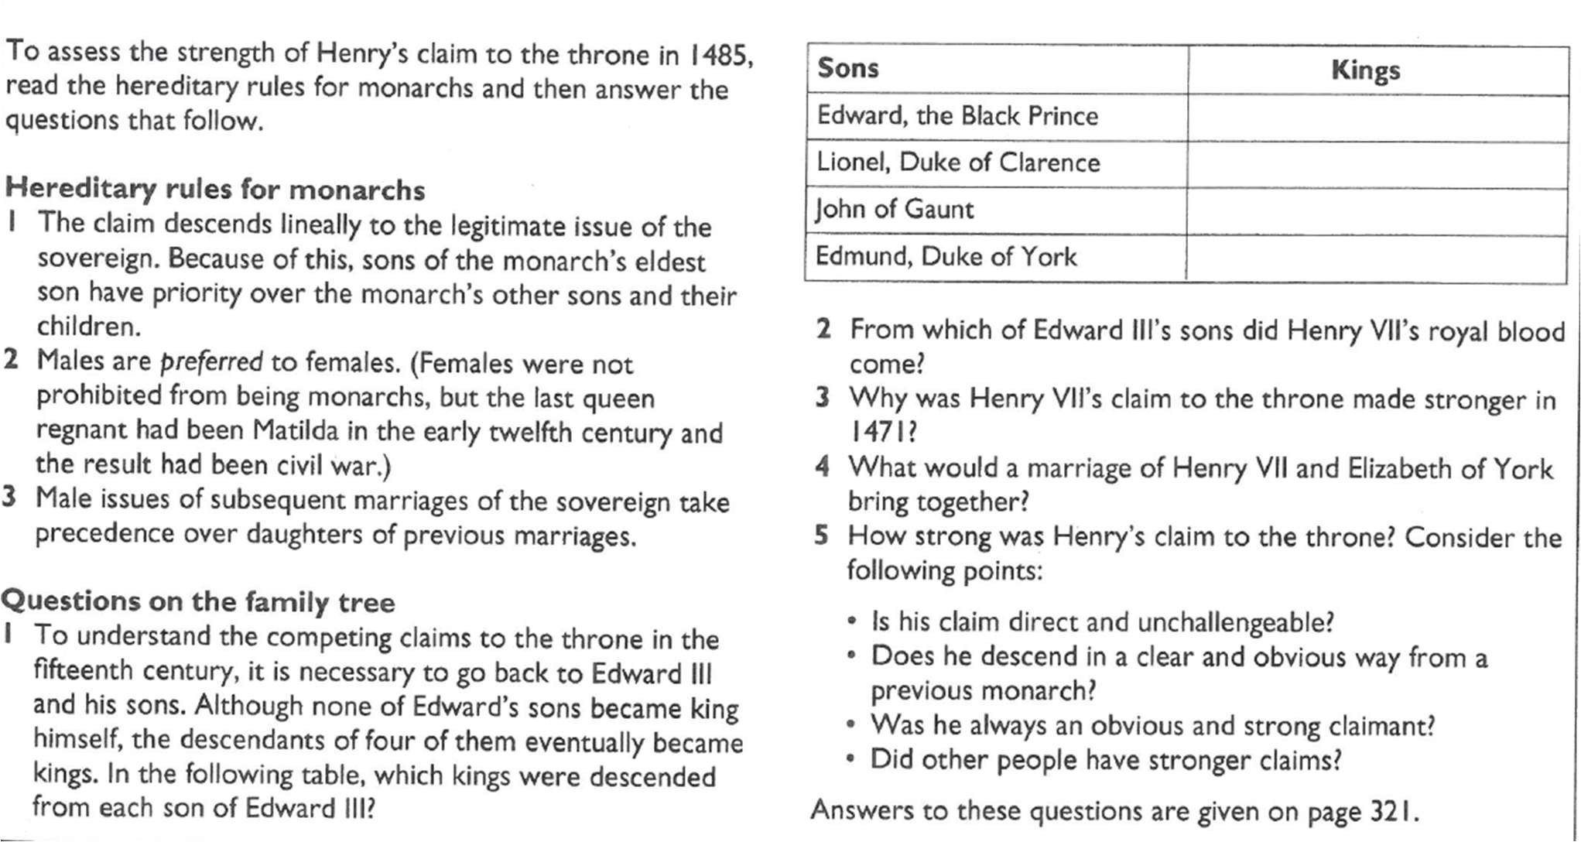
- Complete the following tasks, with reference to the family tree on page 3:
- You will need to bring your answers (handwritten on A4 paper with your name on) to your ﬁrst history class.
- Using the copy of the family tree on page 3, make your own version with the changes a-c added. It can be either done by hand (with images cut out and glued on) or electronically and printed off. Changes to make:
  - Add a contemporary picture of the people shaded yellow (if available).
  - Add a note to say how they become king (if relevant) and how they died
  - Colour code the family tree: red for Lancastrians and white (circle the names with a black line) for Yorkists
- Finally, why are the people marked (*) and (+) so important?

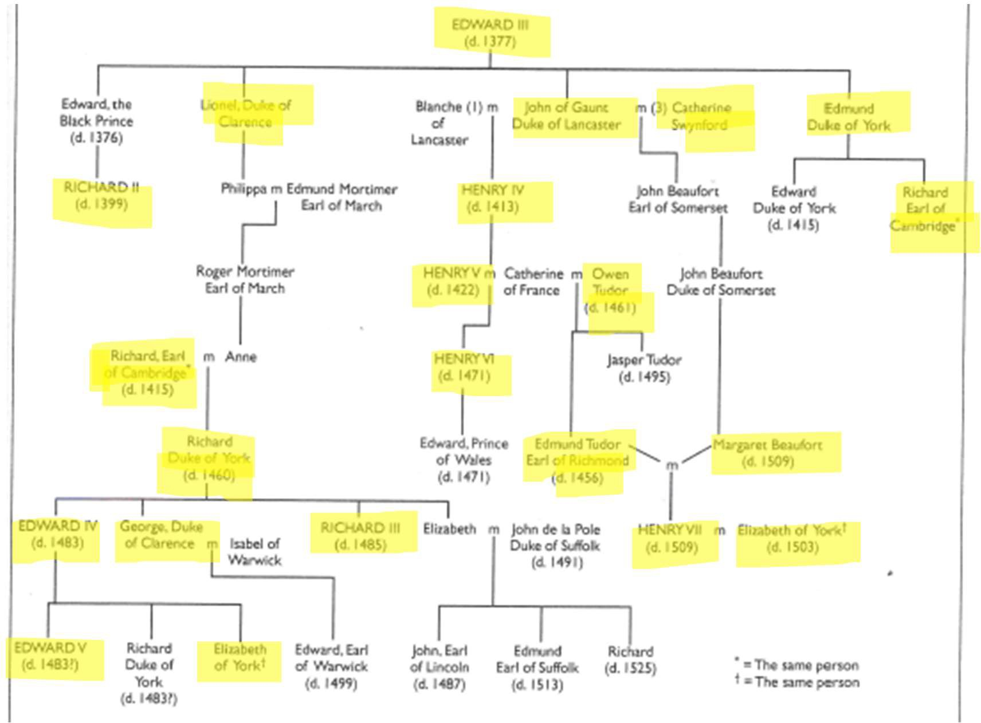
How long should I spend on this? 1hr
How will I get feedback?
Contact email:

