

Level 2 Diploma in Music Performance and Production – Chris Walsh

**Student Name** _______________________________________________

**Homework Task**

Total Time: 6 Hrs  
Sections:  
1. Select 3 songs from different genre’s  
2. Learn the parts for your chosen instrument

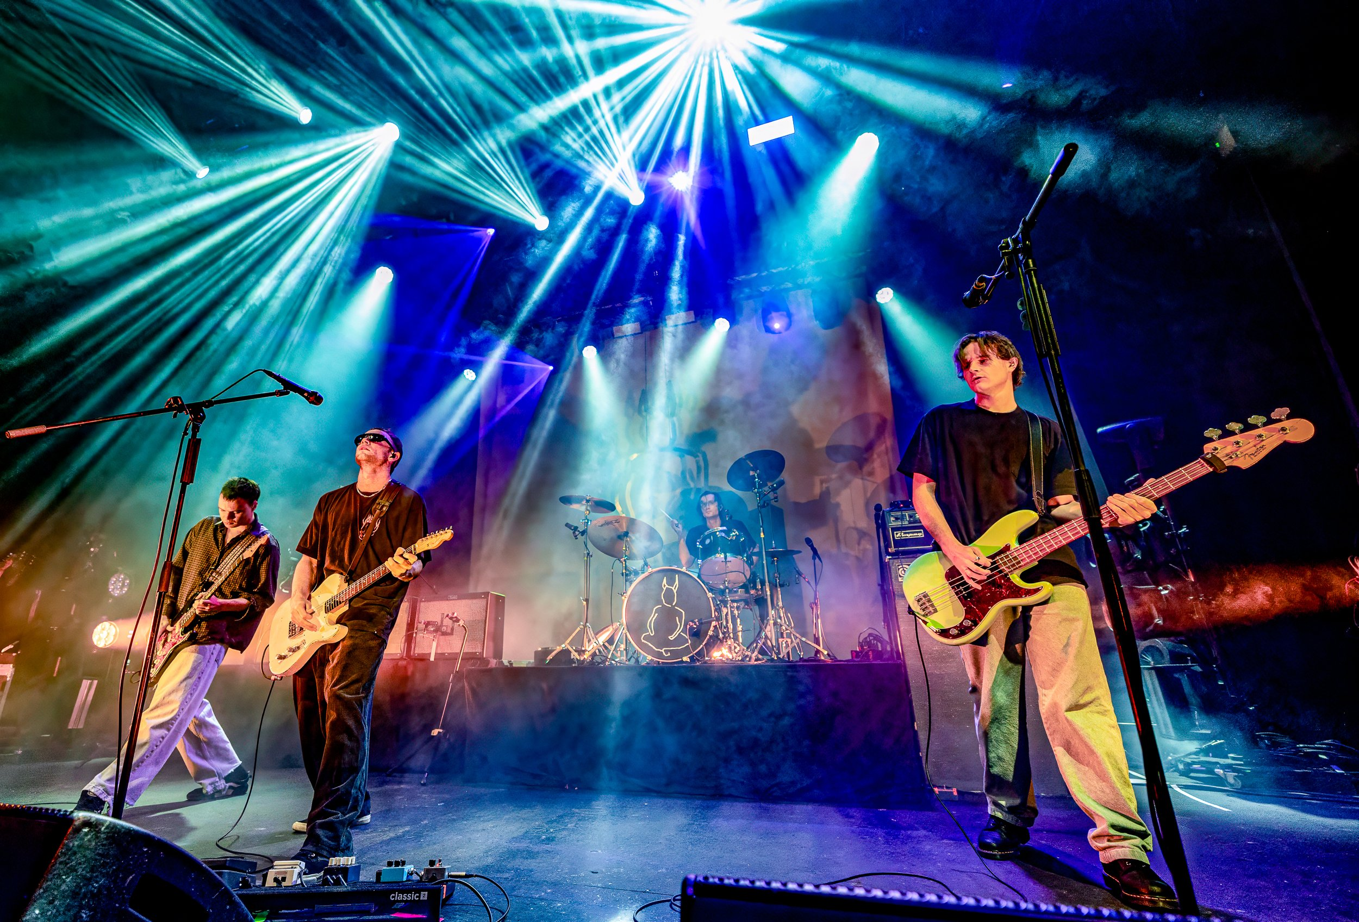

Song 1 ___________________________________________________________________________________

Name of Band/Artist ___________________________________________________________________________________

Genre ___________________________________________________________________________________

Song 2 ___________________________________________________________________________________

Name of Band/Artist ___________________________________________________________________________________

Genre ___________________________________________________________________________________

Song 3 ___________________________________________________________________________________

Name of Band/Artist ___________________________________________________________________________________

Genre ___________________________________________________________________________________