SUMMER TASKS – GCSE TO A-LEVEL TRANSITION
Subject: Geology
Title: Geology Skills
Task(s):
Please bring this to your first lesson when you start in September. There are 2 separate exercises:

Exercise 1: Structure of the Earth

Exercise 1 is to see what you know already about the Earth. There are 4 parts to this exercise:
- Draw a cross-section diagram of the Earth and label the various layers.
- Describe the properties of each layer you have labelled (i.e. is it solid or liquid; can it flow) – do this as a series of bullet points underneath your diagram (make sure you say which layer you are referring to. As well as that;
- Say in your bullet points what the composition of each layer is. This should be at least the chemical composition of the layer (so which elements are found in each layer) and the types of rocks that make up the layer (if you can find this).
- Is there a pattern to the distribution of elements you can see? Is the distribution random or are certain elements concentrated in some layers? Indicate why you think the layers have this composition
Exercise 2: Fossil drawing and labelling:

I want you get used to some of the skills needed in the subject. Two skills in particular are very important; observation skills and drawing skills. For drawing I am not looking for artistic excellence, I am looking for an accurate representation of what is there. You might think you can’t draw, but with sufficient practice anyone can draw fossils, for example, to a good standard.

Draw your own versions of the two fossils shown on the third page: a trilobite and a brachiopod. There are guides below which shows the way to draw the fossils; draw them as accurately as possible in terms of body parts and shapes. NOTE: in order to make sure you don’t just copy them by tracing, I would like you to draw them twice the size they are on the page.

I would also like you to find the appropriate labels for the various body parts. One good source for this are the Fossil Focus pages from the British Geological Survey:
https://www.bgs.ac.uk/discovering-geology/fossils-and-geological-time/trilobites/
https://www.bgs.ac.uk/discovering-geology/fossils-and-geological-time/brachiopods/
Try and get at least 5 labels for each. You may want to do further research on this if you want to get further labels.

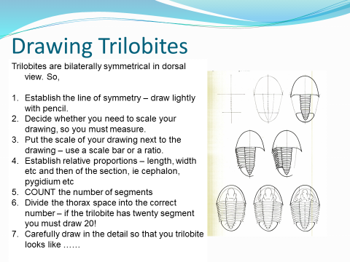
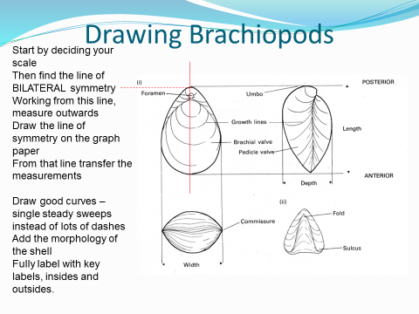

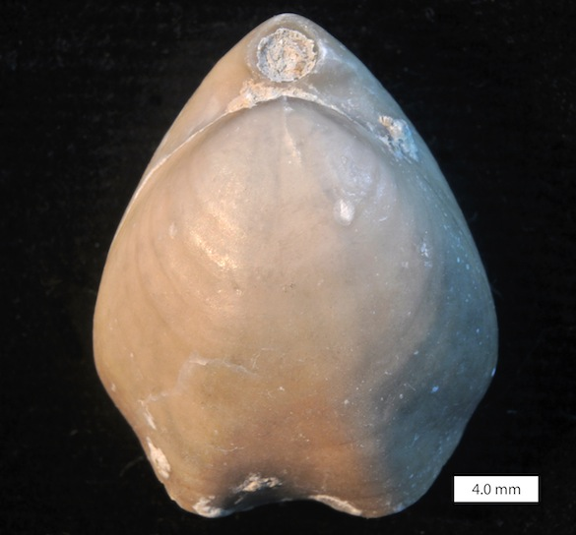
Brachiopod
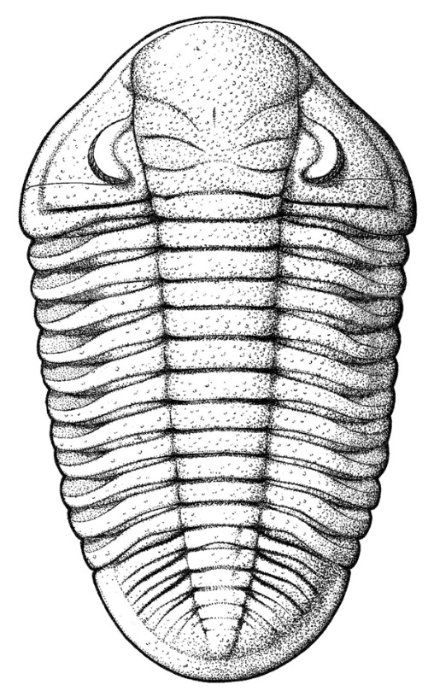
Trilobite

How long should I spend on this? This should take about 1½ to 2 hours at most
How will I get feedback? Written & verbal feedback will be given in September
Contact email: Jon Hickson jhickson@yorkcollege.ac.uk

