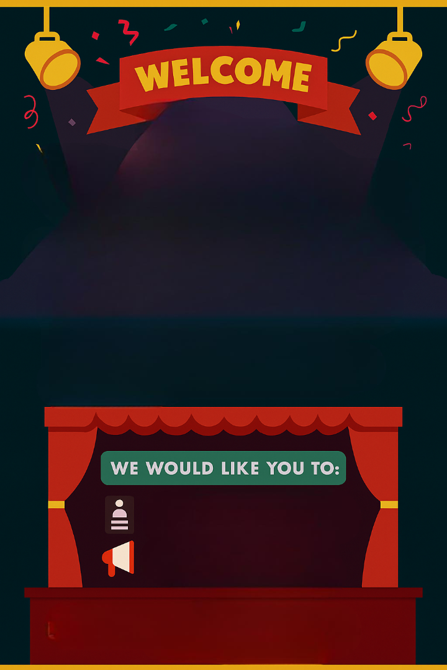
T Level: Media, Broadcast and Production (Events Technician)
We Are asking you to Complete some work over the summer to prepare you for starting the course in September

This work will take you approximately 6 hours to complete
Any Questions, Please Contact Dale Osborne, Course Leader on Dosborne@yorkcollege.ac.uk
Complete the CV Template with as much detail as possible
Watch the video links ready to discuss in class
Dosborne@yorkcollege.ac.uk
CV Template

A Curriculum Vitae (CV) is one of the most important documents to help work placement applications. It is a record of your education, work experience, skills and abilities and is your opportunity to tell employers what you are good at, what you enjoy and why you would be suitable to work for them.
Here is an example template that you can add your own information into. There are some websites below which will give you more guidance as well as ideas for other formats and layouts.

It is important for any work placement requirements to complete your CV before you start at college and keep updating it throughout your time in college. You will have sessions whilst on your programme to develop your CV further during the year.

Always list your newest or most important items at the top of any lists.

Name:

Do not include any other personal contact details on your college CV (Mobile number, email, home address etc)
Personal Profile: | Write a sentence or two that gives key information about you. Think about what makes you unique. Include your career goals or ambitions or why you have decided to complete the course you have enrolled onto.
Skills: | - Choose 4 or 5 key skills you believe you have. Speak to family and friends and see what they suggest as your key skills.  - Try to list a mix of hard and soft skills. Hard skills are teachable abilities such as IT skills. Soft skills are people skills such as teamwork or effective communication.  - Some examples:  I feel I have the following skills:  - Teamwork  - Interpersonal communication  - Time keeping  - Computer skills including word and excel  - Attention to detail  - Being organised  - Being creative  If you can give examples of when you have used that skill either in school, college, home, or hobbies:  - Good at teamwork – worked on a project in a team of 4 at college, allocated tasks and supported each other.
Education:  XXX College  (delete if not appropriate)  XXX School | - List your course/s  - List any other achievements, awards, or recognition  - List your GCSEs and grades  - List any other achievements, awards, or recognition
Modules/Projects | - It may be helpful to add in your list of modules studied on your course  - And/or details of any projects or course work that you think might be of interest to an employer or related to the role/placement.
Work Experience or employment | - Include any part time or holiday work, any volunteering or anything from school. - Employers rarely expect school leavers to have massive amounts of work experience.  - If you have no work experience or employment it is even more important to complete the modules/project section above.  - Do think anything you may have done for family or friends that you might include?  Some examples:  - I have helped at my Grandma’s flower shop, this included making refreshments and cleaning and tidying the shop.  - I have volunteered at local events in my village including the annual scarecrow festival and village fete  - I have been a marshal at our local running event  - I have posted flyers through letter boxes in my neighbourhood to support my Mum’s slimming classes
Hobbies and Interests | What gives an employer a flavour of what you like to do or how you spend your time?  What skills might this give you that could be of interest to an employer?  Some examples:  - I play chess/board games with my family and friends which has helped me to develop patience, tactical and problem-solving skills.  - I play online games/web-based activities which has helped me to develop communication skills, many of my team-mates and competitors are based in other counties or countries. This also helps to keep me up to date with emerging technologies.  - I am a keen social media user which has helped me to become competent in a range of online platforms and keep up to date with developments in the world of social media.  - I play football/netball/etc which has helped me to become an effective team member and improve my communication skills.  - I cook/bake which has helped me to develop time management skills and to carefully follow instructions.  - I babysit for family/friends and this has helped me to develop my caring side as well as communication skills, particularly with people of all ages and be more aware of other’s needs.  - One of my family roles is to walk the dog this has help me to prioritise my time around this responsibility, to be reliable and I have developed awareness of other people’s attitudes and concerns towards dogs and to act appropriately whilst out with the dog.
References: | You can simply state - Available on request. But have a think of who you’d use as your references

Websites
https://nationalcareers.service.gov.uk/careers-advice/cv-sections
https://www.prospects.ac.uk/careers-advice/cvs-and-cover-letters/how-to-write-a-cv
https://www.prospects.ac.uk/careers-advice/cvs-and-cover-letters/example-cvs
https://careers.startprofile.com/page/my-cv

Please also complete the training videos below for the ETC lighting consoles

Eos Family Video Learning Series - YouTube

Device Attributes

