
T-Level Digital Software Development

Pre-course Preparation Activity (Summer 2025)

Hello and welcome to the Digital Software Development T Level

I and the rest of the T level delivery team (Matthew, Elaine, Richard, Steve and Val) are delighted to welcome you to the course.

Firstly, let me extend a warm welcome to each of you. My name is Andy Stanway, and as well as being one of your tutors, I am the course lead for T level Digital Software Development.
This T level is designed to introduce you to the captivating world of computing and the digital landscape.

As we commence this journey together, I'd like to outline a few expectations to ensure a smooth and enriching experience for all.

To begin, we have arranged two tasks for your introduction to the course.
- The first task involves a written analysis, which provides you with an opportunity to express your understanding and thoughts on a specific topic.
- The second task involves a Python coding exercise. Even if you have no prior coding experience, please rest assured that these tasks are designed to be approachable, and you will receive guidance every step of the way.

A significant aspect of this course is the inclusion of a work placement. With this in mind, professionalism is a key attribute that we will be fostering throughout your journey. We understand that challenges may arise, and you might encounter difficulties or even find yourself facing a blank page. Remember, what truly matters is your effort and determination. Don't hesitate to give it your best shot, and don't be discouraged if you encounter challenges.

Submission Procedure
Put everything together into a single document, either in Microsoft Word (doc/docx) format, Office Libre (odt) format or export as Adobe (pdf).
Email your submission to astanway@yorkcollege.ac.uk before the start of term i.e. no later than Sunday 7th September 2025.
You should bring a copy of your work to the first lesson, either printed or electronically on your smartphone/laptop, or email a copy to your student email account at the college (see enrolment information for details).

What happens if I don’t submit the work?
It's natural to wonder about the consequences of not meeting the submission deadline.
- This course is designed to equip you with skills that are highly relevant in a professional work environment.
- Timely and professionally presented submissions are not only a demonstration of your dedication but also a vital part of preparing you for your future career.
- Failure to submit your work could affect your acceptance into the course. However, we recognize that unexpected circumstances can arise.
- If you find yourself facing such circumstances that hinder your submission, please reach out to me before the deadline. We will review these cases individually and consider appropriate measures.

We are here to support you, inspire you, and guide you on this exciting educational journey. If you have any questions, concerns, or require assistance, please do not hesitate to reach out.

TASK 1: Emerging computer technology

In this task you get to investigate any area of emerging computer technology which interests you.
You can pick any area which interests you, but examples could be:
- Artificial intelligence
- Robotics
- Autonomous vehicles
- Virtual Reality
- Biometric security
In no more than ONE side of A4 summarise the area you have chosen under the following four headings:
- What is it?
- Where its used/what id does
- What are the possible Social, Moral, Cultural and Ethical benefits of this technology on society
- My conclusion on this technology and what it will mean for our world 10 years from now.

TASK 2: Python coding

There will be a lot of Python coding on the course and while some of you may be more experienced than others, we want you all to complete the following.

You will need to go to W3Schools, and using the link below, you will arrive at their online Python course. We want you to work your way through the modules identified below. You will also need to keep a development log which should:
- outline the days and times you worked on each of the units.
- what you found easy, difficult or didn’t understand
- a screenshot confirmation of completing each.

W3Schools link: Python Tutorial (w3schools.com)

If the link doesn’t work, then go to any search engine and type: W3Schools Python Tutorials

The website looks like this:
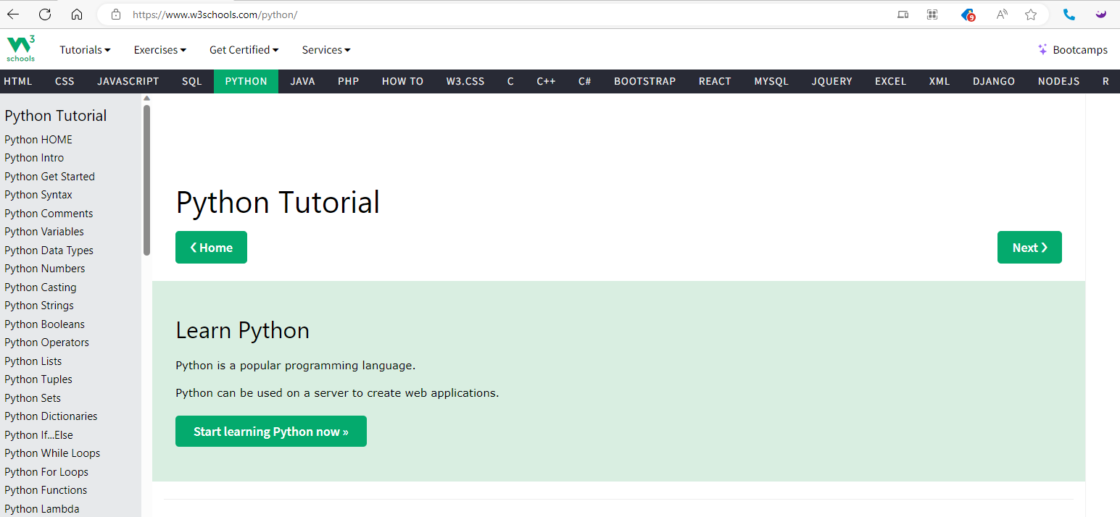

The modules to complete are shown below (you will start with “Home” and work your way down until you complete the “Python Operators” module)
