SUMMER TASKS – GCSE TO Y1 TRANSITION
Subject: Art & Design (Photography)
Title: My first shoot.
Task(s):
Have a look at the following themes and think about ways in which you might respond to them.
- Light & Shadow
- Line
- Urban spaces/architecture
- Reflections
- Abstract/Minimal
- Natural forms
- Texture
Pick your favourite and consider it a bit more carefully, make a list of subject matter ideas and things to think about when shooting. Take 20 images based on these ideas.
Here is an example of how this might look:

TEXTURE:

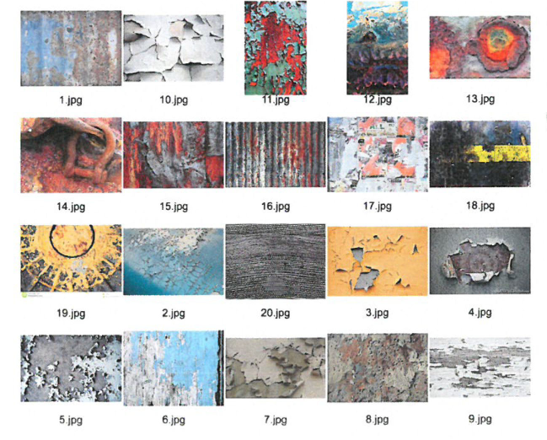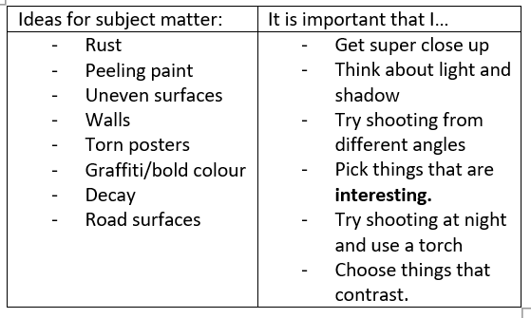

How long should I spend on this? 3-4 hours.
How will I get feedback? On teams in your first week in college.
Contact email: lrigg@yorkcollege.ac.uk

